SECTION 1:

1. Virus Details

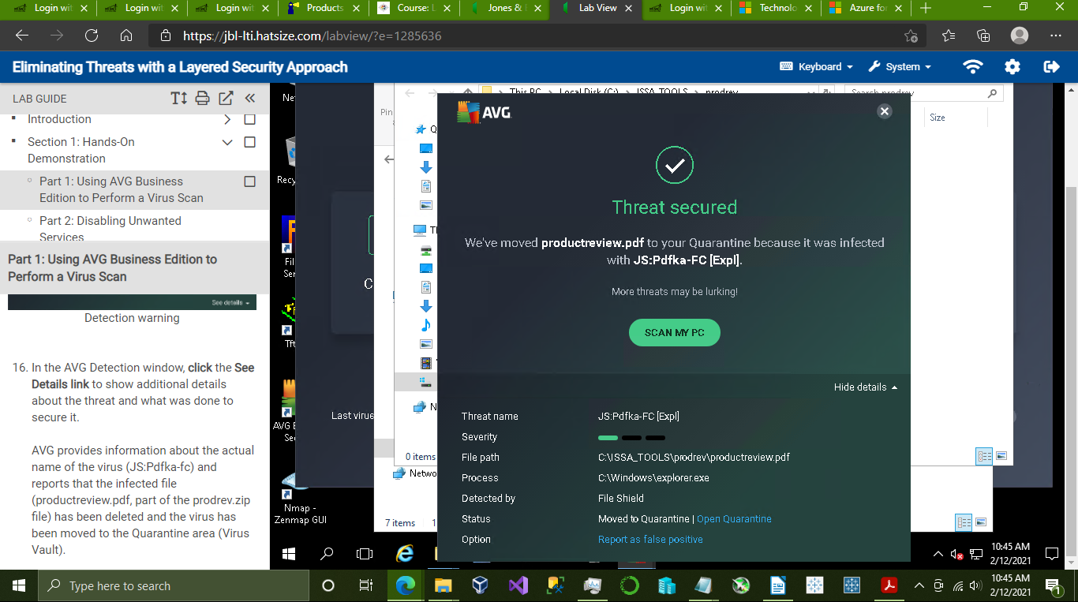

2. Emptied Quarantine area:

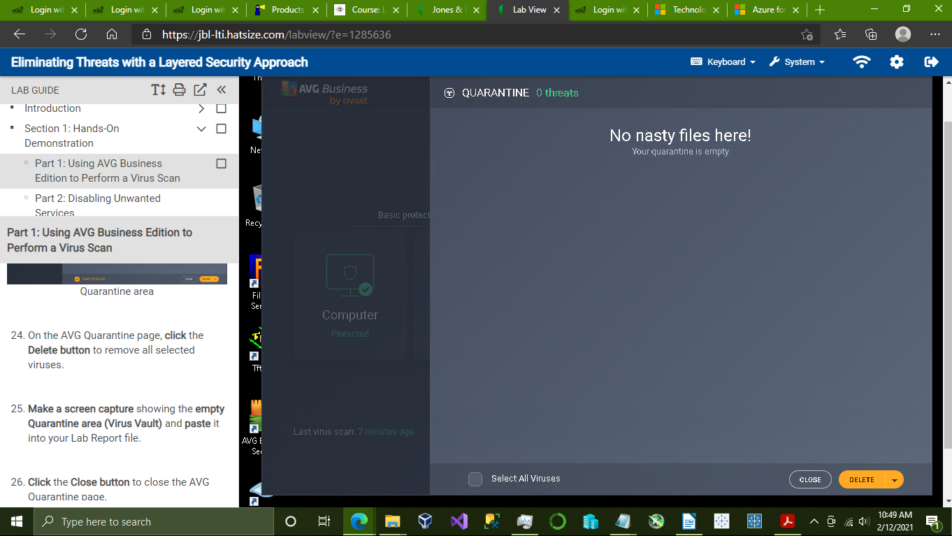

3. Updated services list:

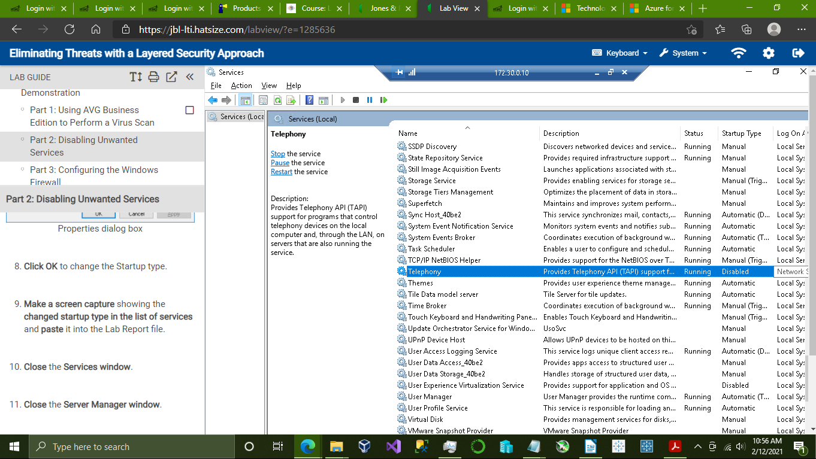

4. Updated File and Printer Sharing rule in the firewall

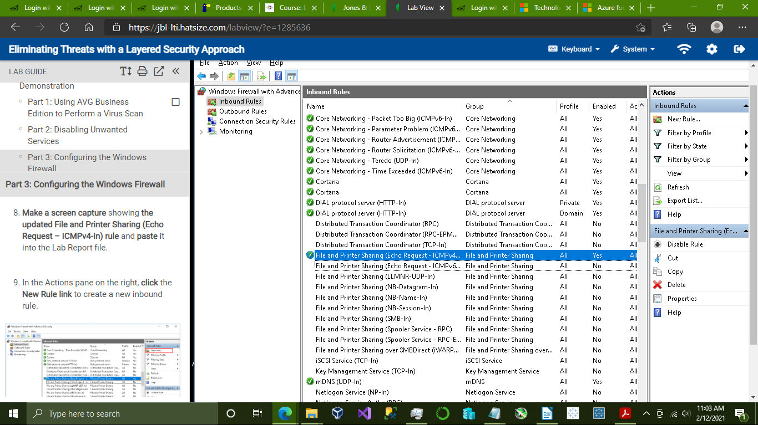

5. Inbound Filezilla Server rule:

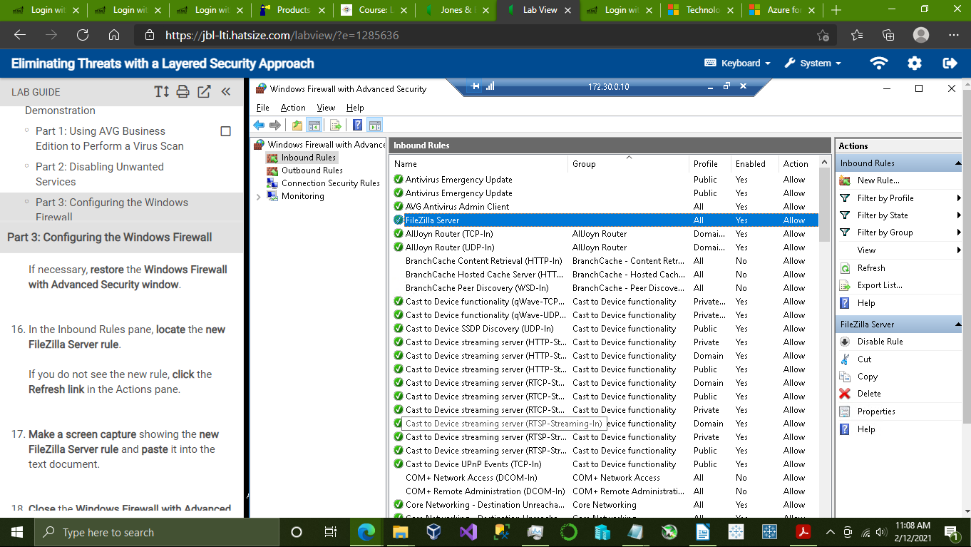

SECTION 2:

1. Scan Summary Detection page:

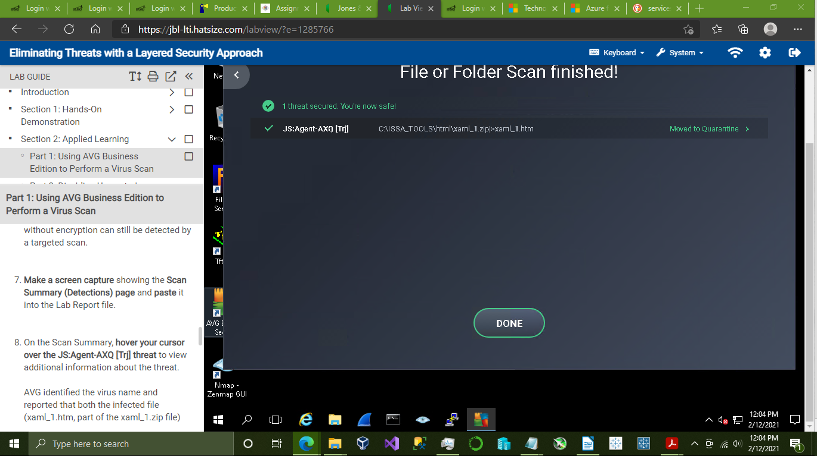

2. Additional threat details:

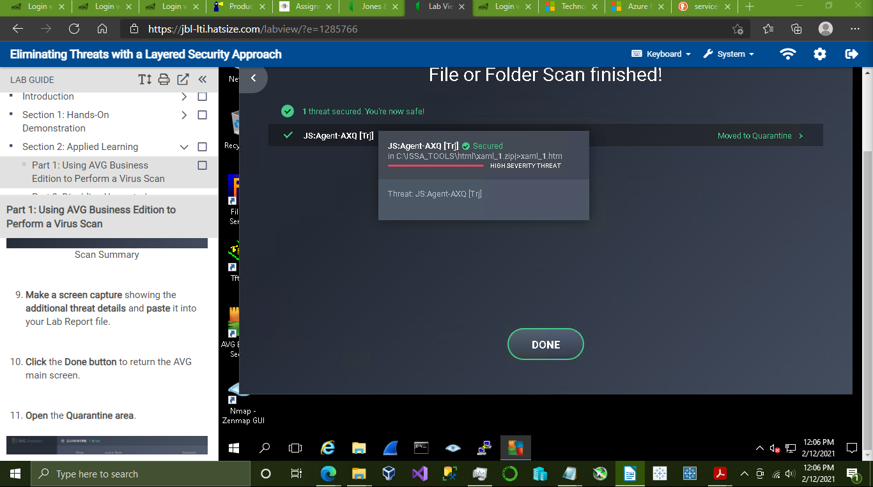

3. Emptied Quarantine area:

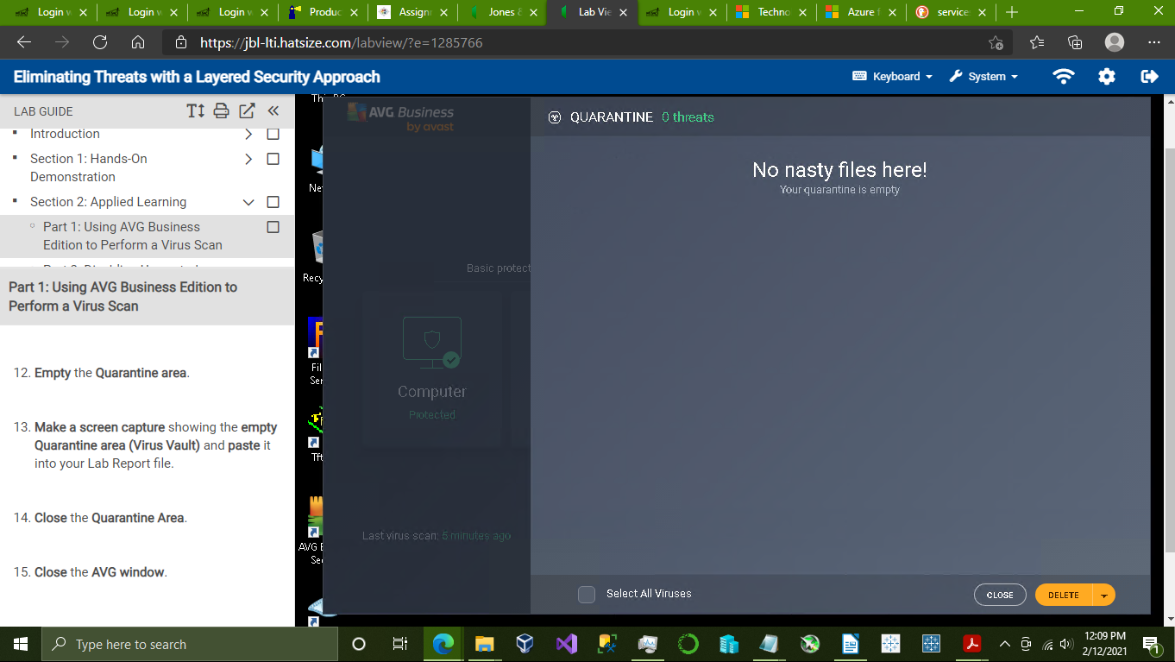

4. Updated Services list: (Bluetooth Support Service, Print Spooler, SNMP Trap Disabled)

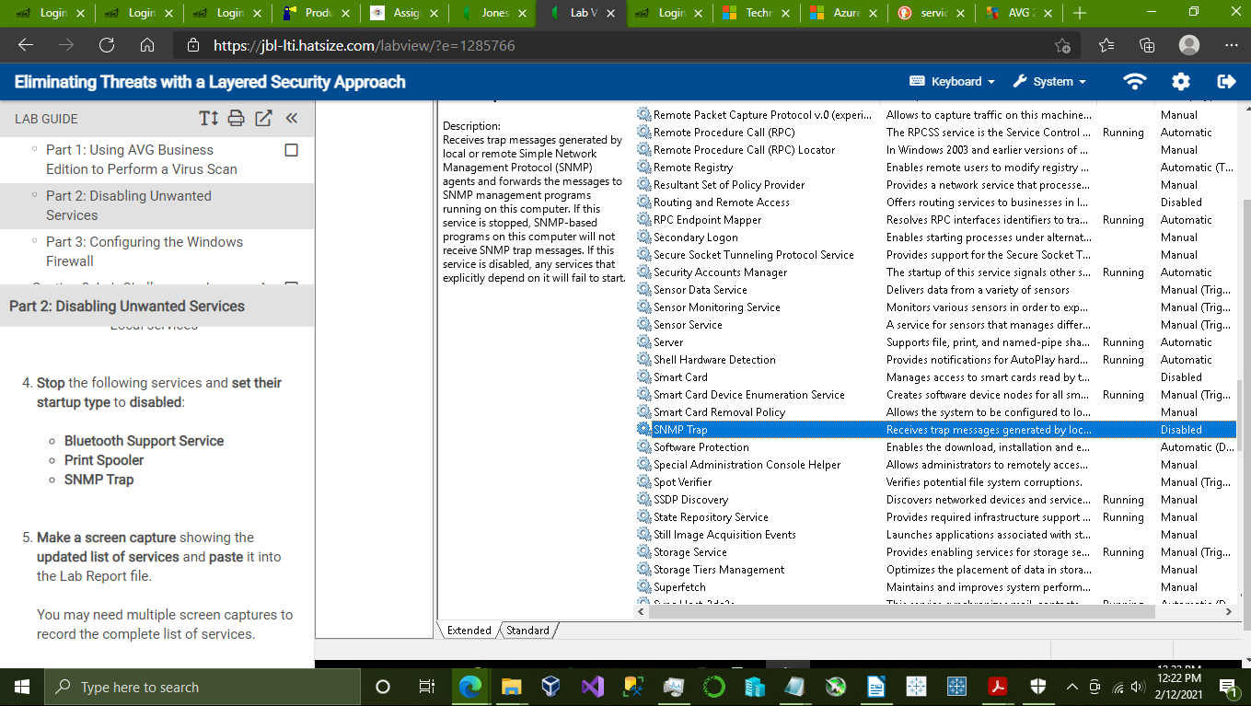

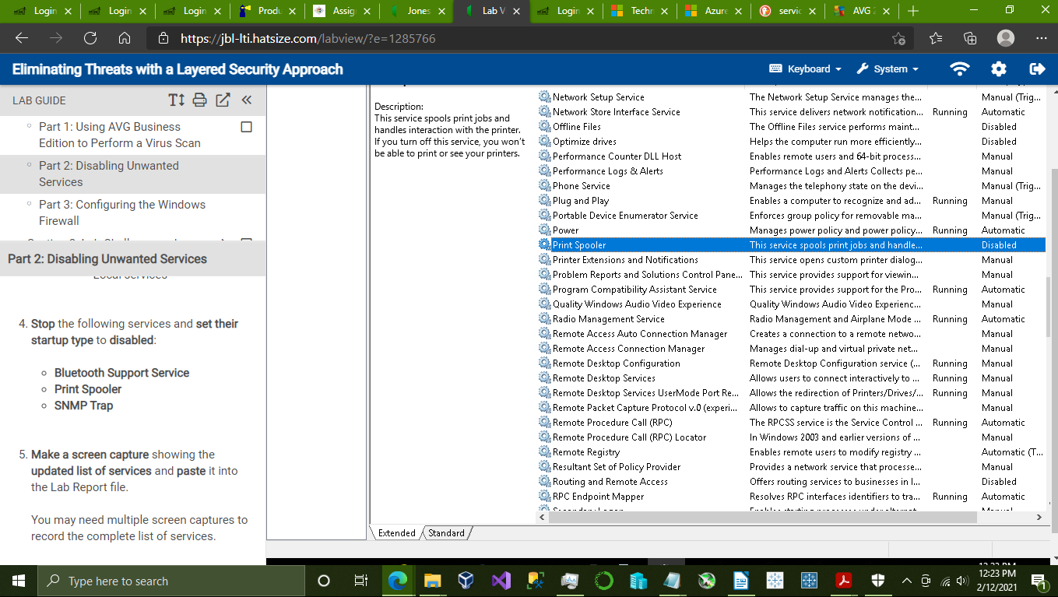

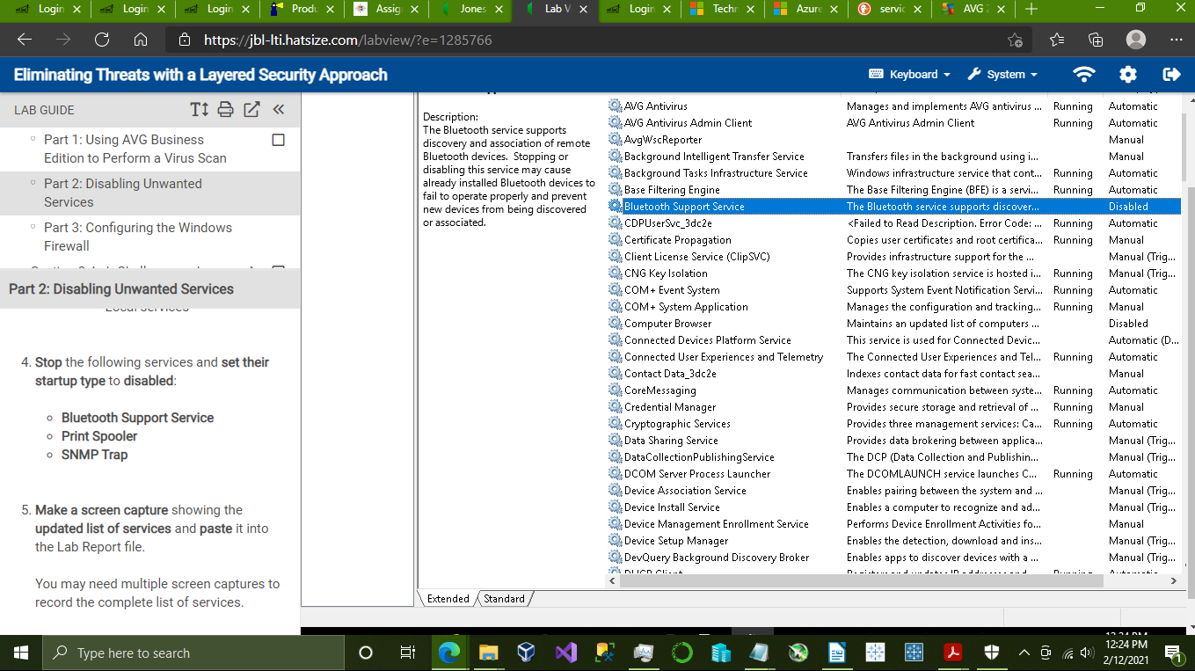

5. Updated Email and accounts rules in the firewall:

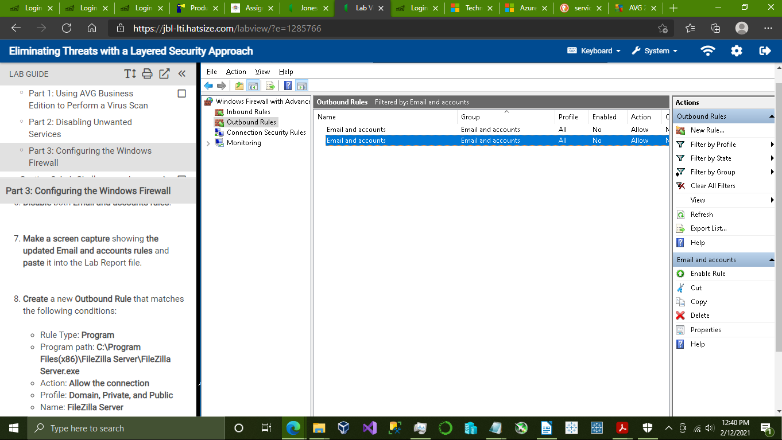

6. Outbound FileZilla Server rule:

